
Welcome to the Department of Software Engineering

Objectives
ADMISSION PEOCEDURE
DATA SCIENCE LAB

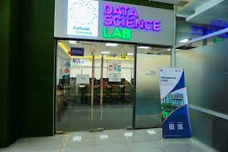
Program Offered

- Software Engineering
- Programming
- Computer System Engineering
- Software Development Engineering
- Software Management Engineering
- Facilities
- Research Facility
- Industry Academia Collaboration
- Modern Lab Facility
CONTACT
Daffodil Smart City, Birulia, Savar, Dhaka-1216
Admission Helpline: +8809617901212
Email: admission@daffodilvarsity.edu.bd

- Why to choose us
- Academic and Industry focus
- Industry Linkage
- Exchange Program
- Global Exposure

A data-driven approach is when decisions are based on analysis and interpretation of hard data rather than on observation. A data-driven approach ensures that solutions and plans are supported by sets of factual information, and not just hunches, feelings and anecdotal evidence.

5 STEPS DESING
INFORGRAPHICS

5 STEPS TEMPLETE

INFOGRAHICS

Industry Academia Collaboration

